Session Façade

An EJB client wants to efficiently invoke methods on multiple EJBs within the context of one use case.
How can an EJB Client invoke methods of multiple session or entity beans in one transaction and one bulk network call?
* * *
Multiple fine grained invocation of session/entity beans adds the overhead of multiple network calls (and possibly multiple transactions), as well as contributes to less maintainable code, since data access and workflow/business logic is scattered across clients.
Consider an online financial banking scenario where a servlet receives a request to transfer funds from one account to another, on behalf of a web client. In this scenario, a servlet must check to ensure the user is authorized, withdraw funds from one bank account entity bean, and deposit to the other bank account entity bean:
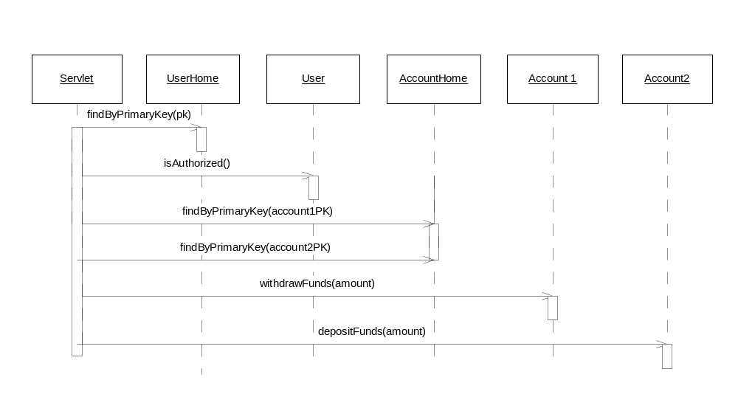
Figure x.x Client and Entity Bean Interaction diagram

When executing methods on the entity beans home and remote interface, this approach will not scale under serious loads, for the whole scenario requires six network calls: three for finding the appropriate entity beans, and three more for actually transferring the funds. If an EJB client is collocated with the EJBs, the use of the local interfaces can help reduce this problem. However, since entity beans are transactional creatures, each method call on an entity will require separate transaction on the server side, each requiring synchronization of the remote entity with its underlying data store and maintenance on behalf of the application server.
Local interface or not, this approach won’t guarantee the safety of the client’s money. If something goes wrong with the deposit, the client’s money would have already been withdrawn, and his money will be lost. The user authorization check, the withdrawal and the deposit all run completely separately, and if deposit fails, the withdrawal will not be rolled back, resulting in an inconsistent state. The problem here is that when calling an entity beans methods directly, each method call is a separate unit of work, and a separate transaction.
One solution is to push extra logic into our entity beans to perform many operations on behalf of a single client call. This solution introduces maintenance problems, because our entity bean layer will likely be used in many different ways over time. If we add application logic to our entity beans each time we need a performance enhancement, our entity beans will quickly become very bloated, and difficult to understand, maintain, and reuse. We are effectively merging our application logic (verbs) with our persistence logic (nouns), which is poor application design.
Another approach is for our client to demarcate an aggregate, large transaction via the Java Transaction API (JTA). This would make each entity bean method call operate under the same transaction, in an all or nothing fashion. If the deposit fails, then the withdrawal will be rolled back and the users’ money will be safe. However, this improved solution also has many drawbacks:
High network overhead. We still have six network calls to deal with, which slows performance (unless using local interfaces).
Poor concurrency. If the client is located very far from the server (such as an applet or application interacting with a remote EJB system, perhaps even across the Internet or a firewall), the transaction will last for a long period of time. This causes excess locking, increasing the chances of collisions or deadlock, and reduces concurrency of other clients accessing the same entity bean instances.
High coupling. Our client writes directly to an entity bean API, which tightly couples the client with the entity bean. If the entity bean layer needs changing in the future, then we must also change the client.
Poor reusability. The business logic that executed the “transfer funds” use-case was embedded directly in the client. It therefore effectively becomes trapped in that client. Other types of clients (java applications, applets, servlets, etc.) cannot reuse this business logic. This mixing of presentation logic with business logic is a poor application design for any serious deployment.
Poor maintainability. Usage of the Java Transaction API causes middleware logic for performing transactions to be interlaced with application logic. It is much cleaner to separate the two via declarative transactions, so that we can tweak and tune our middleware without affecting our business rules.
The takeaway point from our discussion is that we need a server-side abstraction that serves as an intermediary, and buffers calls to entity beans. Session beans are designed just for this.
Therefore,
Wrap your entity beans with one or more session beans. Each session bean should contain application logic to fulfill business use-cases. Each session bean performs bulk operations on entity beans on behalf of a single client request. Clients should have access to session beans only, not entity beans.
To illustrate how this paradigm works, and the benefits of this paradigm, let’s take our previous example. Our business logic for transferring funds will now be placed in a session bean, which has a method called transferFunds(userpk, accountpk, accountpk). If we then add other ancillary banking operations to this session bean as well, we will have a session bean that serves the purpose of a Bank Teller. This session bean will contain business logic or workflow logic that is related to bank accounts. The Bank Teller session bean serves as a wrapper for our Bank Account entity bean and performs bulk operations on Bank Accounts, as in figure XXX.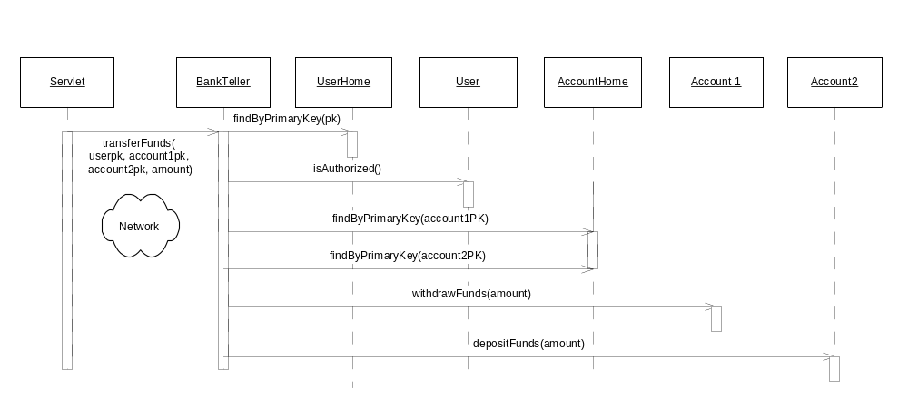
Figure X.X Bank Teller Session Bean Wrapper Interaction diagram

The following are the values to this paradigm:
Low network overhead. While the session bean layer does add an extra layer to call through, the client can now transfer funds in just one network call, rather than six network calls. The benefits far outweigh the drawbacks. This rings especially true as we consider that the application may evolve to be a different beast in the future, accessed by different types of clients that we might not have originally anticipated.
High concurrency. Our session bean encapsulates all logic to perform the bank transfer. The session bean thus acts as a transactional façade, which localizes transactions to the server-side, and keeps them short.
Low coupling. The session bean buffers requests between the client and entity bean. If the entity bean layer needs changing in the future, we may be able to avoid changing the client because of the session bean layer of indirection.
Good reusability. Our bank teller logic is encapsulated into a modular session bean, which can be accessed by any type of client (JSPs, servlets, applications, or applets). The encapsulation of application logic into session beans means that our entity beans can contain data and data access logic only, making them reusable across session beans in the same or even in different applications.
Good maintainability. One could define this transaction declaratively in the Bank Teller session bean’s deployment descriptor, rather than programmatically via the JTA. This gives us a clean separation of middleware and application logic, which increases maintainability and reduces the likelihood of errors.
A clean verb-noun separation. The session bean layer models the application specific usecases, the verbs in our application, while the entity bean layer models the business objects, or the “nouns” in our application. This architecture makes it very easy to map usecases from a requirements document to a real EJB architecture.
The Session Façade pattern is a staple in EJB development. It enforces highly efficient and reusable design, as well as clearly separates presentation logic, business logic and data logic. Session Façade describes a useful architecture for implementing any type of use case, however, if a use case is asynchronous in nature, the Message Façade pattern provides a more scalable approach.

